**CPSC 583 Assignment 2**

**Stacked bar graphs - visualizing UK families’ food purchasing trends**

**By Chi Nguyen**

**10032932**

**Link:** http://pages.cpsc.ucalgary.ca/~nguc/A2/stacked_bars-Chi_Nguyen.html

**Description**

The UK food trends measures foods purchased every week per family in the UK. The foods are separated into general categories and then are categorized further into subcategories. The values given are the amounts of food purchased measured in grams or millilitres.

Being able to visualize what foods families are purchasing can give us insight to how much popular food trends, or even food education programs, are influencing what people buy for their families. This can help us understand how to better educate the population about food choices and maybe see how new products in the market are affecting eating habits as well.

**Directions and change**

Initially, I wanted to represent only the amount of food purchased every week by each family, but realized that it would be missing so much of the context that the subcategories gave, because the amount of food from each category could superficially look the same but on a deeper level we could see that there was a drop in one subcategory and a rise in another. Ignoring the subcategories would cause us to miss details in the data like that situation.

I then decided I wanted to make a visual that would be able to display the different categories and subcategories that were in the data along with the food amounts. In the beginning I debated visualizing the data using a tree map or a sunburst as this would be a way to display all the categories and subcategories in one visual. I decided on a different route though because I thought that displaying all the subcategories at the same time would be overwhelming to the reader, so I decided I wanted to only show one layer of categories at a time, that way the user could take in the data in somewhat smaller chunks, then they could dig deeper into the data if they chose.

In the end I decided on using a stacked bar graph. I went in this direction because the style of the graph allows for easier comparisons of amounts because the bars are aligned side-by-side, unlike in the sunburst where the circular shape somewhat distorts the area. I also like the bar graph because it is familiar and allows the user to quickly understand and see the trends in the data. I wanted the first graph to contain only the data from the desc1 column, this would give the reader the idea of the overall trend found in the data. I then wanted to make it possible for the user to click on a bar, for a particular year, and have it divide into all the subcategories, so that the user would be able to see the breakdown of the types of food purchased.

In the end, I was only able to implement the first layer of the data as well as implement a hover feature that would allow the user to see the amounts purchased in each individual category. This was due to a lack of skill and ability to properly format the data into the appropriate form.

**Representation**

I created a stacked bar graph that represents the total amount of food purchased from each of the main 23 categories. There was 24, but I removed “eggs” due to the unit of measurement being completely different than the rest of the data. For the “amount purchased” values, I assumed that the grams and millilitres were similar units and grouped them.

On the x axis I have the years. I kept all the years in the data because I wanted the user to have a complete view of the data over all the years the data was collected and see if any trends for any specific year had an affect on any of the categories.

My visual is a mapping of the data for the general categories with none of the values changed and units of grams and millilitres ignored, assumed to be the same. The height of the bar represents the value, the width has no meaning, and the colour represents the different categories.

**Presentation**

I wanted to get data from all the years onto the same page so that the user could see the year to year trend. Putting the legend to the side of the chart gives the user an easy reference to the reading the graph. The use of ticks on the axis organizes the data, while the absence lines in the graph area keeps the graph clean. The use of colours for each separate section makes it easier to distinguish them from each other and makes it easy to follow a certain section overtime.

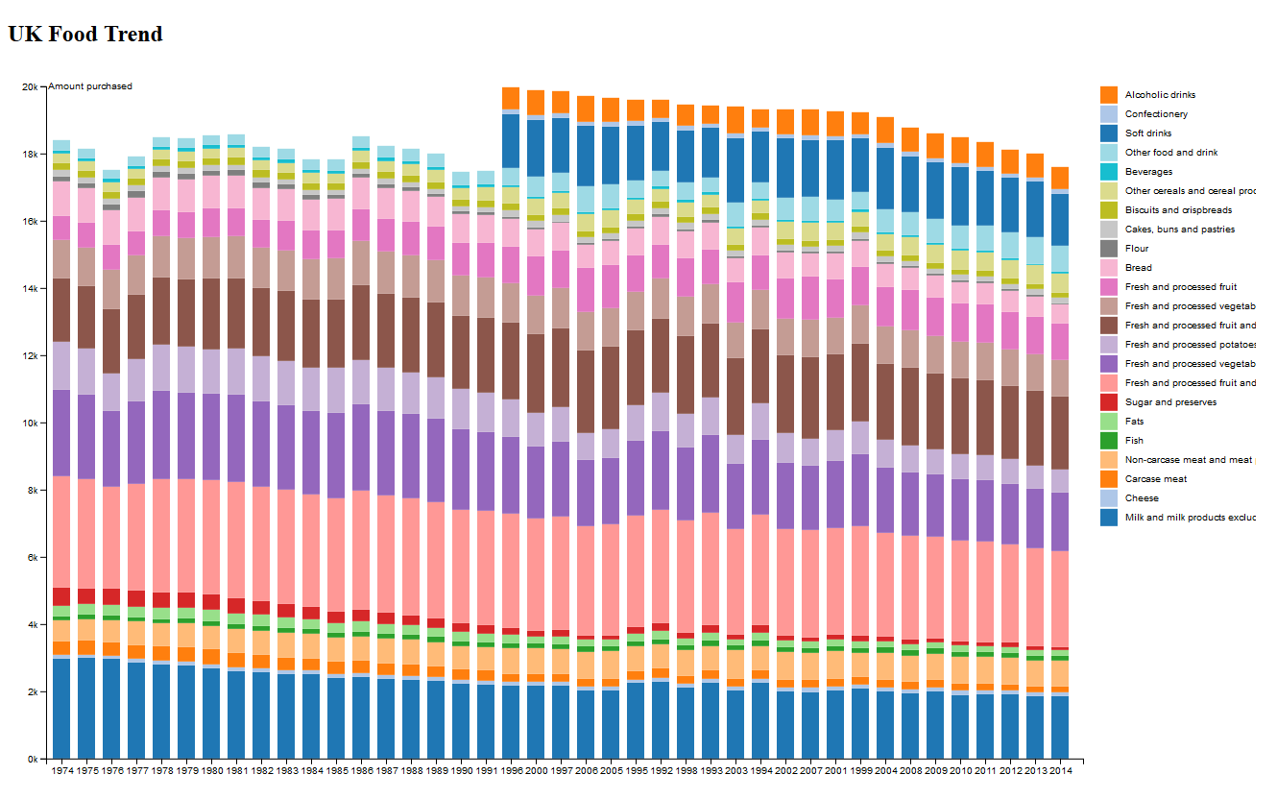

Figure 1: A screenshot of my visual

**Interaction**

When the user hovers over a specific section on a bar it will display the amount purchased from that category.

**Positive features**

Along with being able to see what foods are being purchased from each category we are also able to see how the amount of food being purchased is changing over time as well. We can see that there is an overall decrease in amount of food that families are purchasing over the years. Being able to see trends such as this could lead to studies into what could be the cause for this drop.

This visual also allows us to clearly see when new categories started being added into the data, starting in 1999 three new categories were added. Having the extra categories gives more insight to the purchasing trends of families which would could be helpful in understanding overall purchasing trends.